S. Rushi Keshava Reddy
192472355
CSA 6503 - Generative Ai
CO1-AT1

38.Create a concept map explaining the applications of Generative AI in Engineering.

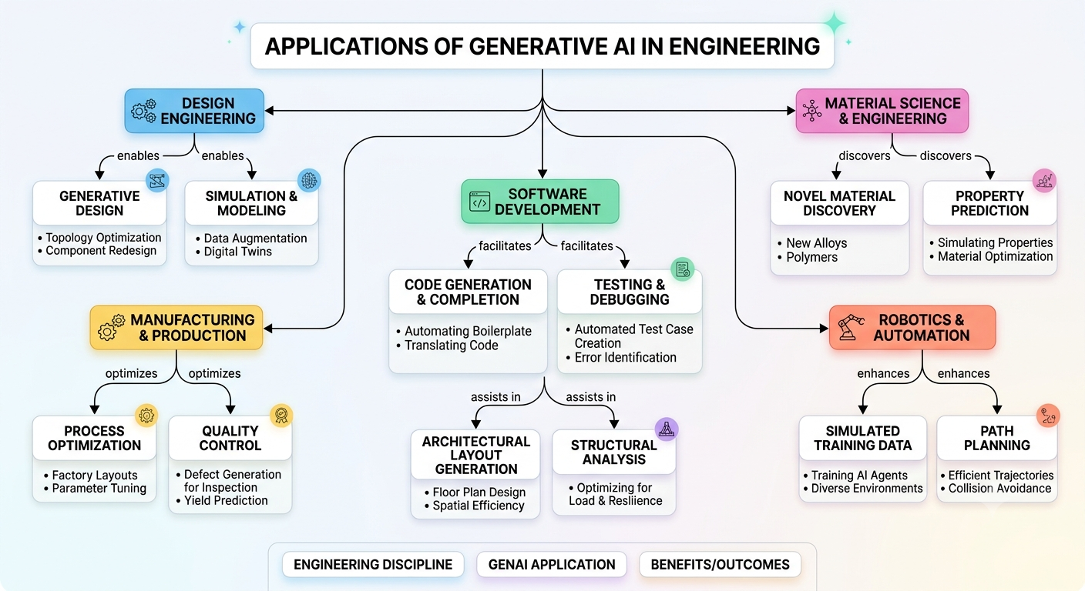

12.Draw a concept map explaining the importance of Embeddings in Transformer models.

